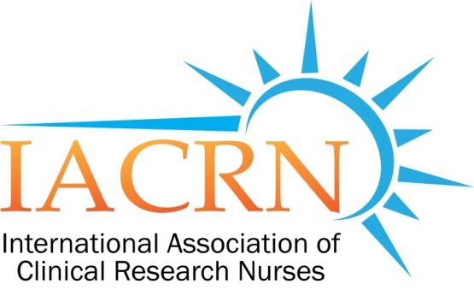

IACRN Research Committee Minutes
Aug 10, 2016

Catherine Griffith - Facilitator | Carolynn Jones | Georgie Cusack
Kathy Grinke | Shaunagh Browning | Rosemary Keller
Members Present

Presiding: Catherine Griffith, Facilitator

- Announcements
  - On August 8th, 2016, ANA has recognized Clinical Research Nursing as a specialty practice
  - Amanda Bray: new member

- Review of July 2016 minutes: Minutes approved as written (RKeller 1st; CTJones 2nd).

- Subcommittee Updates
  - Deviations: Carolynn
    - UAB IRB approved
    - Data collected
    - Need to generate codes from data to be used for data analysis.
    - No preliminary results yet.
    - Project will be ready to present some data in Orlando at October 2016 Conference.

  - Workforce – Discussion related to collated feedback from ISRC (Intramural Scientific Review Committee for Clinical Center Nursing Dept)
    - Background:
      - Cheryl gave a presentation on 6/27 (2016) reviewing/summarizing the Workforce-Domain of Practice proposal (“Expanding the Description of the Clinical Research Nursing Domain of Practice: An International Survey Approach Research” to the ISRC (Intramural Scientific Review Committee for Clinical Center Nursing Dept). The purpose was get feedback and suggestions to strengthen the proposal.
      - 9 people sit on ISRC and attended 6/27 meeting. Guests at 6/27 meeting: Georgie Cusack in attendance and Catherine on the call-in line. Each ISRC member sent back an individual feedback document on July 21 describing comments and questions. These comments and questions (10 documents) were collated and forwarded to Research Committee members on August 2.
    - Research Committee discussion related to ISRC feedback:
      - Many questions/concerns related to
        - Questions on survey:
          - CRNs and/or CRN coordinators engage in many activities which may confuse data. How to formulate clearer questions to make results and data analysis more useful.
          - How to determine who should take the survey?
          - What is criteria for people to self identity if they should participate in survey? Should an initial question ask for a percentage of time the individual engages in patient contact: for example “Do you take care of patients >50% of the time.
          - Maybe ask how the individual self identifies? “Do you self identify as Clinical Research Nurse or Research Nurse Coordinator?
        - Sampling methods: ISRC overall theme that sampling method needs more detail and description of process.
        - Will CRNs from NIH be included in this sample? NIH CRNs participated in original survey. Debate on whether or not NIH CRNs should be included. No resolution yet to this question.
        - Statistician consult needed for formulating questions so that results can be more easily analyzed.
    - Next steps:
      - Need timeline to address the questions/concerns raised in ISRC feedback.
      - Volunteers to address specific areas:
        - Gordon Hill: sampling
        - Other areas to be identified.

- Preconference: Nominal Group
  - 6 members volunteered so far to help with preconference session:
    - Monday, Oct 24, 1pm to 4:30 pm
  - Brief review of process. More detail will be discussed at Sept 14.

- Adjourned at 16:40.

Submitted,
Catherine A. Griffith, PhD, RN
Facilitator

